**Experiment Title 3.2**

**Student Name: Sahul Kumar Parida UID: 20BCS4919**

**Branch: CSE Section/Group: WM-904/B**

**Semester: 5th**

**Subject Name: Project Based Learning using Java**

**Subject Code: 20CSP-321**

**1. Aim/Overview of the practical:**

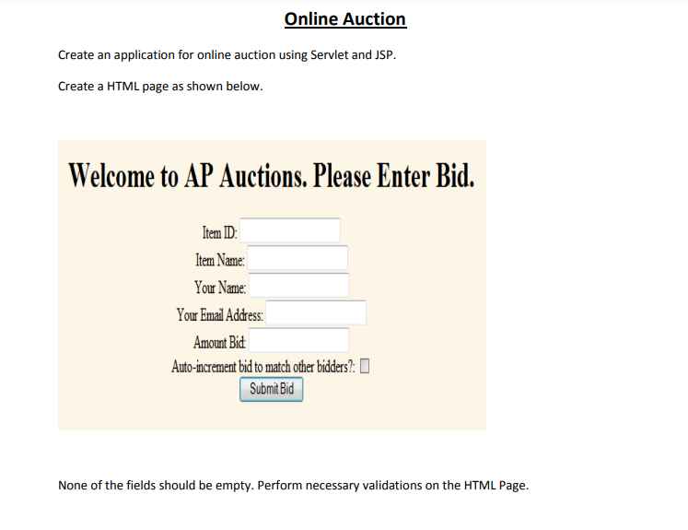

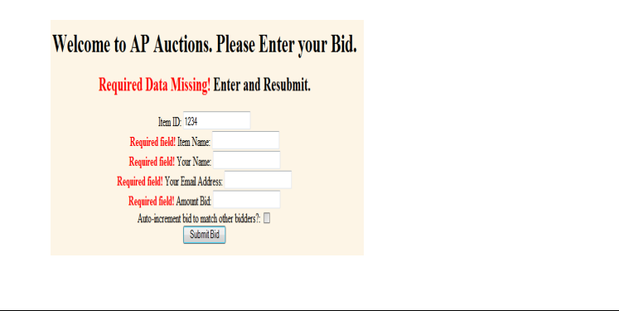

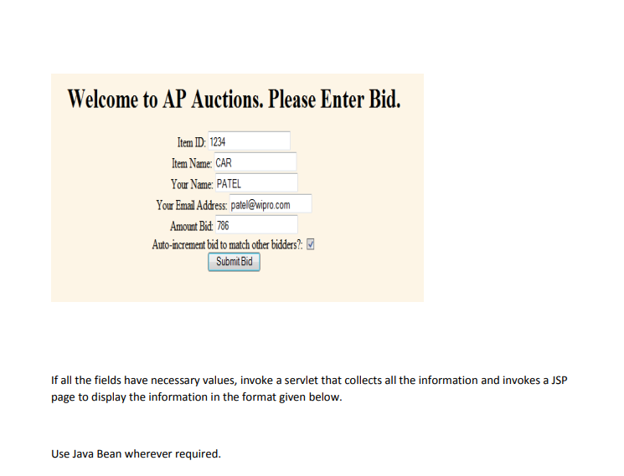

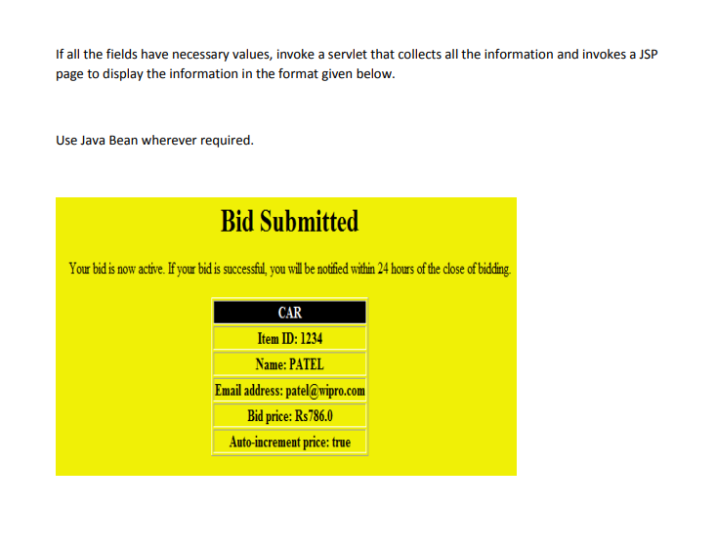

**2. Software/Hardware Requirements:**

# Windows

# BlueJ (Java IDE)

# JRE (Java Runtime Environment)

**3. Steps for experiment/practical/Code:**

display.jsp

<%@ page language=*"java"* contentType=*"text/html; charset=ISO-8859-1"*

pageEncoding=*"ISO-8859-1"*%>

<!DOCTYPE html>

<html>

<head>

<meta charset=*"ISO-8859-1"*>

<title>Online Auction</title>

</head>

<body style="background-color: *rgb(253, 245, 230)*;">

<div style="margin: *200px 400px*; padding: *10px*; width: *700px*; align-items: *center*;">

<h1 style="text-align: *center*;">Online Auction - Made by

Sahul_20BCS4919

</h1>

<h2 style="text-align: *center*;">Welcome to AP Auctions.

Please Enter Bid.

</h2>

<form action = *"details"* style="margin: *5px*; padding: *5px*; text-align: *center*;">

<label for = *"ID"* style="margin: *3px*;">Item

ID:</label>

<input type=*"text"* id=*"ID"* name=*"itemId"*

style="margin: *3px*;"><br>

<label for = *"iName"* style="margin: *3px*;">Item

Name:</label>

<input type=*"text"* id=*"iName"* name=*"itemName"* style="margin:

*3px*;"><br>

<label for = *"pName"* style="margin: *3px*;">Your

Name:</label>

<input type=*"text"* id=*"pName"* name=*"yourName"* style="margin:

*3px*;"><br>

<label for = *"email"* style="margin: *3px*;">Your Email

Address:</label>

<input type=*"email"* id=*"email"* name=*"yourEmail"* style="margin: *3px*;"><br>

<label for = *"bid"* style="margin: *3px*;">Amount

Bid:</label>

<input type=*"number"* id=*"bid"* name=*"Bid"*

style="margin: *3px*;"><br>

<label for = *"button"* style="margin: *3px*;">Auto increment bid to match other bidders?</label>

<input type=*"checkbox"* id=*"button"* name=*"check"* style="margin: *3px*;"><br>

<input type=*"submit"* value=*"Submit Bid"* style="margin: *3px*;">

</form>

</div>

</body>

</html>

display1.jsp

<%@ page language=*"java"* contentType=*"text/html; charset=ISO-8859-1"*

pageEncoding=*"ISO-8859-1"*%>

<!DOCTYPE html>

<html>

<head>

<meta charset=*"ISO-8859-1"*>

<title>Online Auction</title>

</head>

<body>

<%

**if** (request.getParameter("itemId") == ""){

%>

<div style="margin: *200px 400px*; padding: *10px*; width: *700px*; align-items: *center*;">

<h1 style="text-align: *center*;">Online Auction - Made by

Harshit_20BCS5843

</h1>

<h2 style="text-align: *center*;">Welcome to AP Auctions.

Please Enter Bid.

</h2>

<h3 style="text-align: *center*;"><span style="color: *red*">Required data

missing!</span>Enter and Resubmit.

</h3>

<form action = *"details"* style="margin: *5px*; padding: *5px*; text-align: *center*;">

<label for = *"ID"* style="margin: *3px*;"><span

style="color: *red*">Required field!</span>Item ID:</label>

<input type=*"text"* id=*"ID"* name=*"itemId"*

style="margin: *3px*;"><br>

<label for = *"iName"* style="margin: *3px*;">Item

Name:</label>

<input type=*"text"* id=*"iName"* name=*"itemName"* style="margin:

*3px*;"><br>

<label for = *"pName"* style="margin: *3px*;">Your

Name:</label>

<input type=*"text"* id=*"pName"* name=*"yourName"* style="margin:

*3px*;"><br>

<label for = *"email"* style="margin: *3px*;">Your Email

Address:</label>

<input type=*"email"* id=*"email"* name=*"yourEmail"* style="margin: *3px*;"><br>

<label for = *"bid"* style="margin: *3px*;">Amount

Bid:</label>

<input type=*"number"* id=*"bid"* name=*"Bid"*

style="margin: *3px*;"><br>

<label for = *"button"* style="margin: *3px*;">Auto-

increment bid to match other bidders?</label>

<input type=*"checkbox"* id=*"button"* name=*"check"* style="margin: *3px*;"><br>

<input type=*"submit"* value=*"Submit Bid"* style="margin: *3px*;">

</form>

</div>

<%} **if** ((request.getParameter("Bid") == "") &&

(request.getParameter("itemName") == "")){ %>

<div style="margin: *200px 400px*; padding: *10px*; width: *700px*; align-items: *center*;">

<h1 style="text-align: *center*;">Online Auction - Made by

Naman_20BCS2016

</h1>

<h2 style="text-align: *center*;">Welcome to AP Auctions.

Please Enter Bid.

</h2>

<h3 style="text-align: *center*;"><span style="color: *red*">Required data

missing!</span>Enter and Resubmit.

</h3>

<form action = *"details"* style="margin: *5px*; padding: *5px*; text-align: *center*;">

<label for = *"ID"* style="margin: *3px*;">Item

ID:</label>

<input type=*"text"* id=*"ID"* name=*"itemId"*

style="margin: *3px*;"><br>

<label for = *"iName"* style="margin: *3px*;"><span

style="color: *red*">Required field!</span>Item Name:</label> <input

type=*"text"* id=*"iName"* name=*"itemName"* style="margin: *3px*;"><br>

<label for = *"pName"* style="margin: *3px*;">Your

Name:</label>

<input type=*"text"* id=*"pName"* name=*"yourName"* style="margin:

*3px*;"><br>

<label for = *"email"* style="margin: *3px*;">Your Email

Address:</label>

<input type=*"email"* id=*"email"* name=*"yourEmail"* style="margin: *3px*;"><br>

<label for = *"bid"* style="margin: *3px*;"><span

style="color: *red*">Required field!</span>Amount Bid:</label>

<input type=*"number"* id=*"bid"* name=*"Bid"*

style="margin: *3px*;"><br>

<label for = *"button"* style="margin: *3px*;">Auto-

increment bid to match other bidders?</label>

<input type=*"checkbox"* id=*"button"* name=*"check"* style="margin: *3px*;"><br>

<input type=*"submit"* value=*"Submit Bid"* style="margin: *3px*;">

</form>

</div>

<%} **if**(request.getParameter("itemName") == ""){ %>

<div style="margin: *200px 400px*; padding: *10px*; width: *700px*; align-items: *center*;">

<h1 style="text-align: *center*;">Online Auction - Made by

Naman_20BCS2016

</h1>

<h2 style="text-align: *center*;">Welcome to AP Auctions.

Please Enter Bid.

</h2>

<h3 style="text-align: *center*;"><span style="color: *red*">Required data

missing!</span>Enter and Resubmit.

</h3>

<form action = *"details"* style="margin: *5px*; padding: *5px*; text-align: *center*;">

<label for = *"ID"* style="margin: *3px*;">Item

ID:</label>

<input type=*"text"* id=*"ID"* name=*"itemId"*

style="margin: *3px*;"><br>

<label for = *"iName"* style="margin: *3px*;"><span

style="color: *red*">Required field!</span>Item Name:</label> <input

type=*"text"* id=*"iName"* name=*"itemName"* style="margin: *3px*;"><br>

<label for = *"pName"* style="margin: *3px*;">Your

Name:</label>

<input type=*"text"* id=*"pName"* name=*"yourName"* style="margin:

*3px*;"><br>

<label for = *"email"* style="margin: *3px*;">Your Email

Address:</label>

<input type=*"email"* id=*"email"* name=*"yourEmail"* style="margin: *3px*;"><br>

<label for = *"bid"* style="margin: *3px*;">Amount

Bid:</label>

<input type=*"number"* id=*"bid"* name=*"Bid"*

style="margin: *3px*;"><br>

<label for = *"button"* style="margin: *3px*;">Auto-

increment bid to match other bidders?</label>

<input type=*"checkbox"* id=*"button"* name=*"check"* style="margin: *3px*;"><br>

<input type=*"submit"* value=*"Submit Bid"* style="margin: *3px*;">

</form>

</div>

<%} **else** {%>

<%

**int** id =

Integer.parseInt(request.getParameter("itemId"));

String iName =

request.getParameter("itemName").toUpperCase();

String yName =

request.getParameter("yourName").toUpperCase();

String email = request.getParameter("yourEmail");

**int** amount =

Integer.parseInt(request.getParameter("Bid"));

String button = request.getParameter("check");

**boolean** flag = **false**;

**if** (button != **null**){

**if** (button.equals("on")) flag = **true**;}

%>

<div style="margin: *200px 400px*; padding: *10px*; width: *700px*; align-items:

*center*; background-color: *yellow*">

<h2 style="text-align: *center*">Bid

Submitted

</h2>

<p style="text-align: *center*">Your bid is now active. If

your bid is successful, you will be notified within 24 hours of the close of bidding.

</p>

<br>

<table style="margin: *auto*; border:*2px solid black*; text-align: *center*; font-size: *large*;">

<tr>

<th style="border:*2px solid black*;

background-color: *black*; color: *white*"><%=iName %></th>

</tr>

<tr>

ID:

<%=id

%></td>

<td style="border:*2px solid black*;">Item

</tr>

<tr>

<%=yName

%></td>

<td style="border:*2px solid black*;">Name:

</tr>

<tr>

<td style="border:*2px solid black*;">Email

address: <%=email %>

</td>

</tr>

<tr>

<td style="border:*2px solid black*;">Bid

Price: Rs<%=amount %>

</td>

</tr>

<tr>

<td style="border:*2px solid black*;">Autoincrement price: <%=flag%></td>

</tr>

</table>

</div>

<%} %>

</body>

</html>

Details.java

package onlineAuction;

import java.io.IOException;

import java.io.PrintWriter;

import jakarta.servlet.RequestDispatcher;

import jakarta.servlet.ServletException;

import jakarta.servlet.http.HttpServlet;

import jakarta.servlet.http.HttpServletRequest;

import jakarta.servlet.http.HttpServletResponse;

public class Details extends HttpServlet {

public void service(HttpServletRequest req, HttpServletResponse res) throws

IOException, ServletException {

RequestDispatcher rd =

req.getRequestDispatcher("/display1.jsp");

rd.forward(req, res);

int id = Integer.parseInt(req.getParameter("itemId")); String

iName = req.getParameter("itemName").toUpperCase(); String yName =

req.getParameter("yourName").toUpperCase(); String email =

req.getParameter("yourEmail"); int amount =

Integer.parseInt(req.getParameter("Bid"));

String button = req.getParameter("check");

System.out.println("Item id is: " + id);

System.out.println("Item name is: " + iName);

System.out.println("Your name is: " + yName);

System.out.println("Email is: " + email);

System.out.println("Amount bid is: Rs" + amount);

}

}

web.xml

<?xml version=*"1.0"* encoding=*"UTF-8"*?>

<web-app xmlns:xsi=*"http://www.w3.org/2001/XMLSchema-instance"*

xmlns=*"https://jakarta.ee/xml/ns/jakartaee"* xmlns:web=*"http://xmlns.jcp.org/xml/ns/javaee"*

xsi:schemaLocation=*"https://jakarta.ee/xml/ns/jakartaee https://jakarta.ee/xml/ns/jakartaee/web-*

*app_5_0.xsd http://xmlns.jcp.org/xml/ns/javaee http://java.sun.com/xml/ns/javaee/web-*

*app_2_5.xsd"* id=*"WebApp_ID"* version=*"5.0"*>

<display-name>onlineAuction</display-name>

<welcome-file-list>

<welcome-file>index.html</welcome-file>

<welcome-file>index.jsp</welcome-file>

<welcome-file>index.htm</welcome-file>

<welcome-file>default.html</welcome-file>

<welcome-file>default.jsp</welcome-file>

<welcome-file>default.htm</welcome-file>

</welcome-file-list>

<servlet>

<servlet-name>details</servlet-name>

<servlet-class>onlineAuction.Details</servlet-class>

</servlet>

<servlet-mapping>

<servlet-name>details</servlet-name>

<url-pattern>/details</url-pattern>

</servlet-mapping>

</web-app>

**4. Result/Output/Writing Summary:**

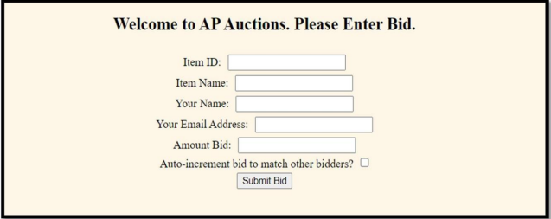

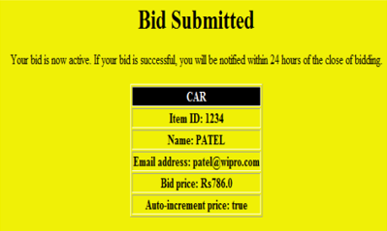

**Learning outcomes (What I have learnt):**

1. Learnt about Servlet.
2. Learnt about jsp and their functions.
3. Classes in Java.
4. Collections in Java.